CRT-310-N (USB)
Firmware Programming Instruction
V 1.1

Creator (China) Tech Co ., Ltd
2018-06-19

USB programming instruction
- Install programming software（skip if you already installed）
unpack“CRT_IAP_20170207.rar”
“20170207”is version.

- Connect module power and data cables.

- open“CRT_IAP_RD.EXE”, click to select “USB Interface”。

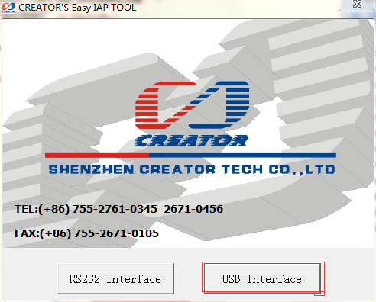

- access to the mode select icon, click to select“CRT-310N”：

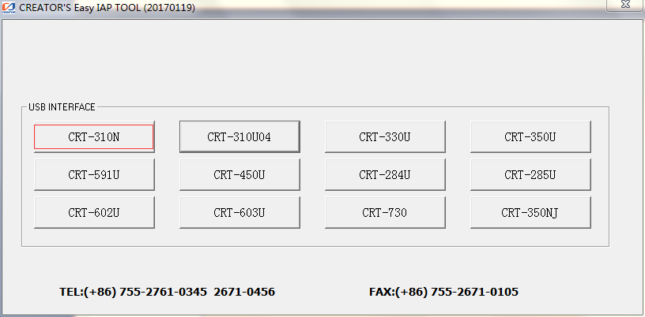

- access to the programming firmware icon
it should display“ICRW is Disconnected” at the time
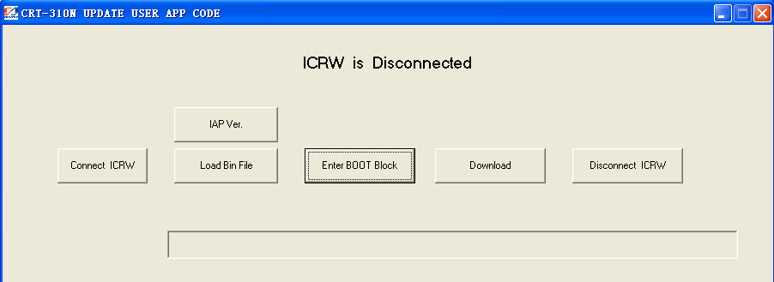

- Click “Connect ICRW” button， pop“Communication Setting”dialogue as follows:
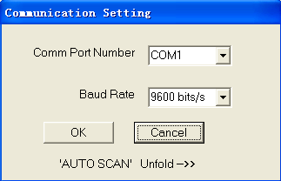

click“AUTO SCAN Unfold”，steps to：

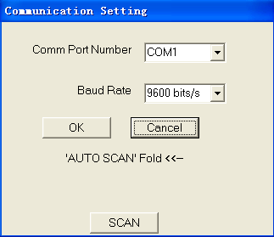

- click“SCAN” button, if module is connection correctly, it will display module connection port and baud-rate, shown as follows. Otherwise please check power and data cables condition. Click “OK” to return programming icon.

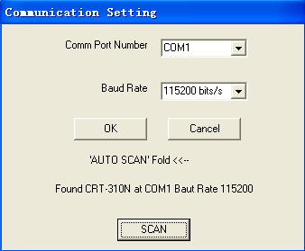

Programming icon shows“ICRW Has been connected”。

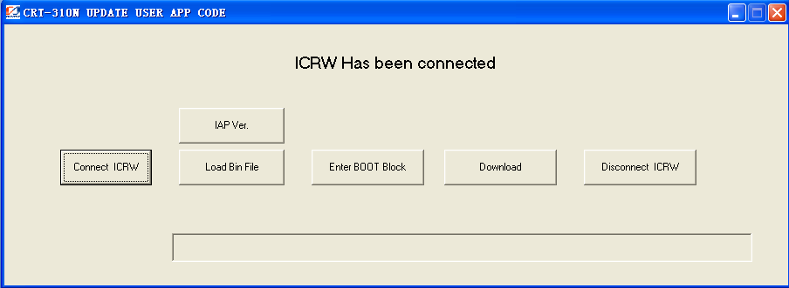

- Click “Load Bin File” button to select programming file, such as “C310_NR01_A_151022.bin”。
click “确定” when follows icon is shown:

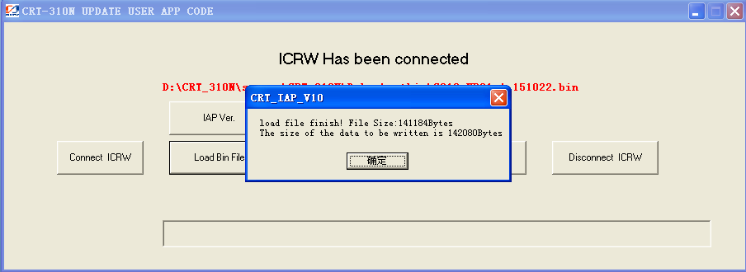
- Click “Enter BOOT Block” button, access into programming status

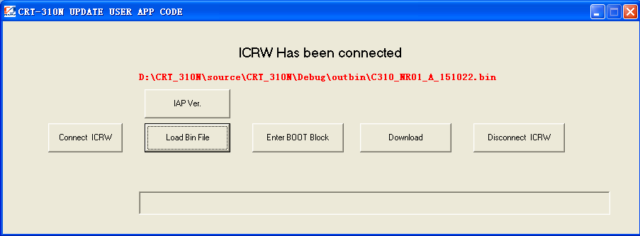

click “确定” after pop follows dialogue frame, at the time the indicators此on module will start to flash (4 times / 1 sec)
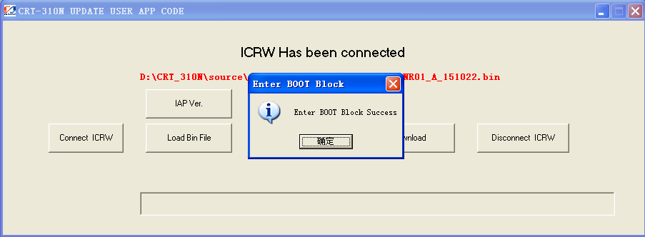

- Click “Download”， start burning firmware

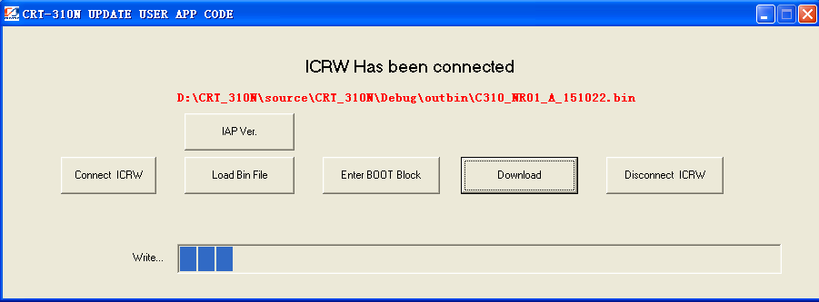

- Pop follows dialogue frame after finish programming.

